**Multiple Sensor Fusion for Human Activity Recognition**

**Project Proposal**

**Team Members:**

Ashwin Jagadeesha

Ronaldson Bellande

Jay Pandya

**Abstract** – Deriving activities of humans from a video feed is a laborious activity and directly falls into the domain of computer vision but is susceptible to noise from various sources although the methods are accurate with the surge in current Computer Vision and Computing capabilities there is definitely a scope for improvement in the activity recognition. While, tagging the actions being performed by a human from a video feed with high accuracy is a quality of an Intelligent AI based activity recognition system. However, in safety critical applications it is imperative to utilize multiple sensor modalities for robust operation. To exploit the benefits of state-of-the-art machine learning techniques for Activity Recognition (AR), it is valuable to have multi-modal datasets.

Using camera to determine what Interaction needs to be recognize the environment and the Human Activity. In general, Activity recognition is to identify the set of actions and objectives of one or more objects from a series of examination on the action of object and their environmental condition. The major applications of Human Activity Recognition vary from Content-based Video Analytics, Robotics, Human-Computer Interaction, Human fall detection, Ambient Intelligence, Visual Surveillance, Video Indexing and so on.

In this project we also aim to examine the challenges, and issues of Human Activity Recognition systems. There are a lot of variants in Human Activity Recognition systems such as Human Object Interactions and Human-Human Interactions etc. We intend to create a dataset which collects different activities from this sensor fusion and study their properties whose findings are used to create an accurate mapping from data to activity using Machine Learning and Deep Learning to determine what Human activity is being performed.

**Brief introduction into Human Activity Recognition**

Human Activity Recognition system gains its popularity due to the increase in number of surveillance cameras. The goal of activity recognition is to identify the actions and objectives of one or more Human from a series of examination on the action of Human Activity and their environmental condition. As single activity corresponds to many elementary actions, applications of this system are not limited to surveillance security, sports, and context-based retrieval.

**Problem statement**

The main research questions of this project fall under the three categories.

How can an effective system be built to detect activities of humans and tag them correctly?

How to create a mapping between different Sensors such as Camera, LIDAR (Light Detection and Ranging), and Infrared sensors for detecting different human activity.

How to efficiently use Deep Learning and Neural Network with Cameras to separate the Human activity from other activities and objects in the world.

What additional techniques need to be applied to record data from these sensors and the structure of data?

**Approach**

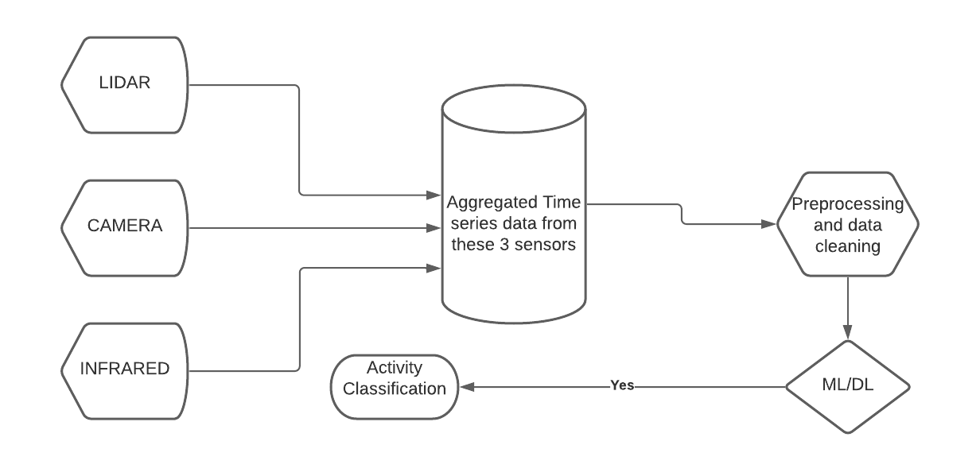

*Fig 1: Process Layout*

**Approach and Deliverables**

* Use camera to determine that sensor data is useful for the Human Activity Recognition
* Read data from the sensors in Figure [1]. Create a dataset with time stamped data for each sensor.
* Develop an architecture that would fuse all the 3-sensor data into dataset for classification.
* Develop additional architecture to separate the objects from the Human activity using camera.
* Preparing the data for machine learning by improving the quality of the data using statistical approaches.
* Create a feature vector from the data above.
* Develop a machine learning model that accepts the feature vector from the above sensor fusion data.
* Tune the model to provide accurate classification.
* Study the results and find areas of improvement and if DL would work better in that situation.

**References**

**[1]** [**https://core.ac.uk/download/pdf/48295879.pdf**](https://core.ac.uk/download/pdf/48295879.pdf)

**[2]** [**https://arxiv.org/ftp/arxiv/papers/1901/1901.02858.pdf**](https://arxiv.org/ftp/arxiv/papers/1901/1901.02858.pdf)